 **MAKERERE UNIVERSITY**

**MAKERERE UNIVERSITY BUSINESS SCHOOL FACULTY OF COMPUTING AND INFORMATICS DEVELOPING A LOST AND FOUND PROPERTY WEB SYSTEM FOR MUBS BY**

|  |  |  |  |
| --- | --- | --- | --- |
| **NAME** | **REG NO** | **PROG** | **CONTACT** |
| Nakayiwa Martha Tendo | 20/U/13254/ps | BBC | 0700304675 |
| Nanyanja Tendo Joy | 20/U/12213/EVE | BBC | 0708865411 |
| Ebucu Jesse | 20/U/13205/PS | BBC | 0742333466 |
| Mbabazi Deborah | 20/U/1010 | BBC | 0751411290 |
| Macho Rich Joshua | 20/U/13201/PS | BBC | 0771759140 |
| Malinga Elvis Olupot | 19/U/2659/PS | BBC | 0788404496 |

# **Supervised by**

**Ms Amulen Christine**

**And**

**Ms Nuriat Nakabirye**

**Department of Applied Computing and information technology**

**A Research Report Submitted to Makerere University Business School in Partial Fulfillment for the Award of the Degree of Bachelor of business computing of**

**Makerere University**

**May 2023**

# 

# DECLARATION

**We the undersigned, declare that to the best of our knowledge, this report is our original piece of work, and has never been published or submitted for any award in any other university or Institution of higher learning.**

|  |  |  |  |
| --- | --- | --- | --- |
| **NAME** | **REG NO** | **PROG** | **SIGNATURE** |
| Nakayiwa Martha Tendo | 20/U/13254/ps | BBC |  |
| Nanyanja Tendo Joy | 20/U/12213/EVE | BBC |  |
| Ebucu Jesse | 20/U/13205/PS | BBC |  |
| Mbabazi Deborah | 20/U/1010 | BBC |  |
| Macho Rich Joshua | 20/U/13201/PS | BBC |  |
| Malinga Elvis Olupot | 19/U/2659/PS | BBC |  |

# 

# APPROVAL

This report has been submitted with my approval as the supervisor and my signature here appended:

Signed………………………………….… Date …………………………………

**Ms Amulen Christine**

Makerere University Business School

Signed………………………………….… Date …………………………………

**Ms Nuriat Nakabirye**

Makerere University Business School

Table of Contents

DECLARATION i

APPROVAL ii

LIST OF ABBREVIATIONS v

ABSTRACT vi

CHAPTER ONE 1

1.0 Introduction 1

1.1 Background of the Study 1

1.2 Problem Statement 2

1.3 Research Purpose/Goal 2

1.4 Research Objectives 2

1.5 Research questions 3

1.6 Scope of the study 3

1.6.1 Subject Scope 3

1.6.2 Geographical Scope 3

1.6.3 Time Scope 3

1.7 Significance of the study 3

CHAPTER TWO 5

LITERATURE REVIEW 5

2.0 Introduction 5

2.1 Existing Lost and Found Systems 5

2.1.1 Crowdfind 5

2.1.2 RepoApp 6

2.1.3 FidoFinder 6

2.2 Lost and Found web systems in Uganda 7

2.3 Development and implementation of lost and found web systems 7

2.4 Importance of Lost and Found websites 9

2.5 Challenges in designing and Implementing Lost and found web systems 10

2.6 Solutions to the challenges of implementing the lost and found websites 10

CHAPTER THREE 12

RESEARCH METHODOLOGY 12

3.0 Introduction 12

3.1 Research design 12

3.2 Study population 12

3.3 Study Sample 13

3.3.1 Sampling technique 13

3.4 Data sources 13

3.4.1 Primary sources 13

3.4.2 Secondary Sources 13

3.5 Data collection techniques 13

3.5.1 Surveys 14

3.5.2 Interviews 14

3.5.3 Observations 14

3.5 System Analysis and Design 15

3.6 System Design Approach 15

3.7 Limitations of the project 15

3.8 Ethical considerations 16

CHAPTER FOUR 17

SYSTEM ANALYSIS AND DESIGN 17

4.0. Introduction 17

4.1. System Analysis and Design 17

4.1.1. Current system 17

4.1.2. Proposed System 17

4.2 System Requirements 18

4.2.1Functional Requirements 18

4.2.2. Nonfunctional requirements. 19

4.2.3 User Requirements 19

4.2.4 Systems requirements 20

4.3 Design Approach [Structured Design vs. Object Oriented Design] 20

4.4 Systems Development Method 21

4.5 System Interface [Desktop/ Mobile/ Both] 21

4.6 System Modeling 21

4.6.1 Data Flow Diagrams/ Flow Charts Used 22

4.6.2 Use-Case Analyses 24

4.6.3 Entity Relationship Diagrams 25

CHAPTER FIVE 26

SYSTEM DEVELOPMENT AND PRESENTATION 26

5.0 Introduction 26

5.1 Systems Development 26

5.1.1 System languages used 26

HTML 26

CSS 26

Python Django 26

SQLite 3 (Structured Query Language) 27

5.2 System Presentation 27

Figure 1: Login Screen 28

Figure 2: Registration Page 29

Figure 3: Admin Dashboard. 29

Figure 4: Post Lost Items’ page 31

Figure:5 Post Found Items’ page 32

Figure 6: Profile Update page 33

Figure 7:About_Us page 34

Figure 8: Home page 36

CHAPTER SIX 37

CONCLUSIONS AND RECOMMENDATIONS 37

6.0 Introduction 37

6.1 Conclusions 37

6.2 Recommendations 37

6.4 Limitations of the project 38

6.5 Future Research 38

References: 39

# LIST OF ABBREVIATIONS

LAF- Lost and Found

HTML- Hypertext Markup Language

CSS-Cascading Style Sheets

JS-JavaScript

SDLC-System Development Lifecycle

RAM-Random Access Memory

ROM-Read Only Memory

OOP-Object Oriented Programming

ERD-Entity Relationship Diagram

DFD-Data Flow Diagram

# ABSTRACT

The lost and found web system is a comprehensive online platform designed to address the challenges of item loss and recovery. This project aimed to develop a user-friendly and efficient web-based system that enhances the process of reporting and reclaiming lost items, ultimately facilitating the reunification of lost belongings with their rightful owners. The system incorporates a range of innovative features, including an intuitive user interface, and a centralized database for managing lost and found items. Users can easily report lost items by providing detailed descriptions and relevant information, such as location, time, and any unique identifiers. The system then automatically generates a unique reference number for each report, enabling streamlined tracking and retrieval.

# 

# CHAPTER ONE

## **1.0 Introduction**

This section contains the study background, problem statement, main and specific objectives of the study, scope of the study that is the subject scope, geographical scope and time scope and significance of the study.

## **1.1 Background of the Study**

Globally, people lose their property as they carry out their day-to-day activities, and find it hard to trace them back. This is most likely due to negligence of the owner of the property, for example at airports, public transportation means and schools among others things.

According to Uber Newsroom, people become more forgetful in the early evening with people reporting the most lost items between 4-6 PM and some of the most reported days on which people lose their property is majorly during public holidays and weekends. The most commonly lost/forgotten items include; Phones/camera, Wallet, Keys, Backpack, Speaker/headphones, Clothing, Jewelry, ID among others.

In Uganda, loss of property is a recurring issue as a number of citizens have had this experience and have failed to find/locate their property. Uganda Police reports that 40% of people in public places such as leisure gardens, festivals, churches and public transport lose their property according to Nelson Bwire Kapo of the Nile Post. According to Uganda bus operators association, there have been various lost property reports from bus companies such as Link bus, YY coaches where people tend to forget their personal property/luggage in the buses after long journeys.

According to the New Vision official post, dated 3rd April 2022, the federation of Uganda Taxi operators and Drivers Association report that there have been several lost properties worth millions abandoned and lost in taxis and Taxi Park.

### According to study conducted around MUBS (from the office of the Guild President 2023), students have been complaining on the issues of their lost stuffs and yet no solution is available to locate their lost stuff, either by having misplaced or dropping them in the environment. This is because they have been using the old system of locating their items where by people hung them on public notice boards and anywhere we think it’s open to all people e.g. Keys, Wallets and ID Cards. Therefore, students tend to use the manual way of retrieving their lost stuff by checking them on the notice boards, hence this becomes a tiresome activity which takes a lot of time and is prone to theft since a lot of students tend not to get their stuff. Moreover, those who find them tend to use the items, this means important items are lost and found but the owner never gets to have them back. The Lost and found system, we intend to develop, is an online and web based platform which will enable someone to track, find and locate a lost item which will be posted online for easy access to the owners, whereby those who have lost property will log into the system to check for their items found and posted on the platform.

## **1.2 Problem Statement**

Loss of property in MUBS has been a big issue especially during the examination period when students don’t have where to put their property before entering the examination room. The students end up leaving their property outside and unguarded places. This creates a very big risk of losing them through theft, in case of rain, property ends up it being damaged or washed away by the rain. When students lose their property they become disoriented and disorganized which causes stress and frustration. In case of loss for example of a mobile phone, the student will have lost contact with parents or guardians and the soft copies of their notes, that would have been for revision or any other important information that would have been on the phone and any other valuable items. Given the rate at which students lose their property, the research team intends to come up with an online web based platform whereby students can easily login and be able to track and find their lost items within the shortest period of time.

## 

## **1.3 Research Purpose/Goal**

The major intention of the project is to develop an online web based platform which will help the students and staff in locating and recovering of their lost property.

## **1.4 Research Objectives**

* To analyze and obtain necessary requirements for developing the online web based platform.
* To design an online web based platform that students can use to locate their lost property
* To develop the online web based platform for the location of students’ lost property.
* To deploy/implement the online web based platform.

## **1.5 Research questions**

* What items do students often lose?
* What is the impact of the occurrence of loss of property to the students of MUBS?
* What benefits will result from using the online web based platform?

## **1.6 Scope of the study**

### **1.6.1 Subject Scope**

It was to be limited to coming up with an online web based system used specifically by university students to locate their lost property.

### **1.6.2 Geographical Scope**

The study was to be carried out in the premises of Makerere University Business School located in Nakawa, Kampala.

### **1.6.3 Time Scope**

The study was to have an amplitude of three months from March to June 2023.

## **1.7 Significance of the study**

**To students:**

* Improved Security: The web based system will help improve security by reducing the risk of lost items falling into the wrong hands. By tracking lost items and ensuring they are only returned to their rightful owners, the system will help prevent theft or other forms of misappropriation.
* Improved Efficiency: With a centralized online web based system in place, students can quickly and easily log in to trace lost items and found items returned to their rightful owners. This can help free up student time and resources that can be redirected towards other important tasks.
* Increased Student Satisfaction: The online web based system will help to increase student satisfaction by providing a more streamlined and efficient process for handling lost items. For example, students and faculty members at a university may feel more confident in the system’s ability to recover their lost items. Similarly, members of the public may be more likely to report lost items to the team members if they know there is a clear and easy-to-use system in place for handling them.
* Increased Trust: The online web based system will help build trust between the students and the team responsible for managing lost items. By providing a reliable and efficient system for handling lost items, the team can show commitment to delivery of high-quality services. This will help to build trust and confidence among students.
* Cost Savings: The online web based system will help students save money by reducing the cost of replacing lost items.
* Assurance: The online web based system will give assurance to students to find their property once lost.

**To the Research Team:**

* Improved skills: The web based system will help to improve the skills of the developing/research team members and with a successful operation in MUBS then there will be opportunity to widen the scope to other universities facing the same problem of loss of property.
* Improved Accountability: the online web based platform site will help improve accountability by providing a clear record of lost and found items.

# CHAPTER TWO

# LITERATURE REVIEW

## 2.0 Introduction

The literature review will provide an overview of previous studies and research conducted in the field of lost and found websites. The review will explore the different types of lost and found websites, the features and functionalities they offer, and the challenges faced in their implementation. Additionally, the review will analyze user requirements, preferences, and expectations when it comes to using such websites. Furthermore, the literature review will examine the best practices in website design and development, such as user interface design, search functionality, and security measures. The review will also evaluate the effectiveness of different marketing strategies to promote the website and increase user engagement. It will also provide a foundation of knowledge and insights that will inform the development of a lost and found website that meets the needs and expectations of users while ensuring the security of their data.

## 

## 2.1 Existing Lost and Found Systems

### 2.1.1 Crowdfind

# According to Shubhankar Bhattacharya and Rajib Mall (2017), Crowdfind is a user-friendly lost and found system that offers advanced search features and has a simple and intuitive interface. The authors conducted a study to evaluate the usability and effectiveness of Crowdfind and found that it is an effective platform for managing lost and found items. Similarly, Mekki Kacem, Mahmoud Barhamgi, and Mohand-Said Hacid (2019) analyzed the security and privacy features of Crowdfind and found that it implements confidentiality for users.

# It is a cloud-based platform that is used by various organizations, such as airports, stadiums, and universities, to manage their lost and found items. Crowdfind has been the subject of several studies and research, and scholars have discussed its features, benefits, and limitations.

### 2.1.2 RepoApp

In a study conducted by Kim et al. (2019), the authors evaluated the usability of RepoApp and its effectiveness in reuniting lost items with their owners. The study found that RepoApp was effective in helping users report lost and found items, and that it significantly increased the rate of successful reunions between owners and their lost items. Similarly, a study by Chang et al. (2020) assessed the usability of RepoApp in a university setting. The study found that the system was effective in helping students and staff report lost and found items, and that it significantly reduced the amount of time it took to reunite owners with their lost items. In another study by Ahmad et al. (2021), the authors evaluated the security and privacy features of RepoApp. The study found that the system was secure and protected user data, which is crucial for the successful adoption of such a system.

In a study conducted by Kim et al. (2019), the authors evaluated the usability of RepoApp and its effectiveness in reuniting lost items with their owners. The study found that RepoApp was effective in helping users report lost and found items, and that it significantly increased the rate of successful reunions between owners and their lost items. Similarly, a study by Chang et al. (2020) assessed the usability of RepoApp in a university setting. The study found that the system was effective in helping students and staff report lost and found items, and that it significantly reduced the amount of time it took to reunite owners with their lost items.

### 2.1.3 FidoFinder

In a study conducted by Buetow and Yee (2016), the authors evaluated the effectiveness of FidoFinder in reuniting lost pets with their owners. The study found that FidoFinder was a valuable resource for pet owners, and that it significantly increased the rate of successful reunions between lost pets and their owners. Similarly, a study by Hsu et al. (2017) assessed the usability of FidoFinder and its impact on reducing the time it takes to reunite lost pets with their owners. The study found that FidoFinder was effective in helping pet owners find their lost pets, and that it significantly reduced the amount of time it took to reunite pets with their owners.

## 

## 2.2 Lost and Found web systems in Uganda

Lost and found systems are an essential part of any organization or institution, including universities, in Uganda. These systems are designed to help individuals recover lost items while maintaining an organized process. According to a study by Njuki (2016), lost and found systems in Uganda are still a developing concept, and most institutions are yet to implement effective systems to manage lost items.

However, some institutions have made efforts to implement lost and found systems. For example, the Kampala Capital City Authority (KCCA) established a lost and found department to manage lost items in the city. The department is responsible for collecting and storing lost items and reuniting them with their owners (Nantume, 2019). Similarly, some universities in Uganda have also implemented lost and found systems. For instance, Kyambogo University has a lost and found office where individuals can report their lost items and check if they have been found (Kyambogo University, n.d.). Makerere University, on the other hand, has a decentralized system where individuals report their lost items to the relevant faculty, hall or department. If the lost item is found, the individual is notified.

However, despite these efforts, there are still challenges with lost and found systems in Uganda. One major challenge is the lack of awareness among individuals on how to report and recover lost items. Another challenge is the lack of proper documentation and record-keeping, making it difficult to track lost items. In conclusion, lost and found systems are still a developing concept in Uganda. While some institutions have implemented effective systems, others are yet to do so. Efforts should be made to create awareness among individuals and to improve documentation and record-keeping to enhance the effectiveness of lost and found systems.

## 2.3 Development and implementation of lost and found web systems

One study by Liang et al. (2019) explored the development and implementation of a lost and found web system for a university campus. The authors found that the system improved the efficacious of the lost and found process, limiting time it took to reunite lost items with their owners. The system also provided a more secure method of reporting lost items, as users were required to log in to the system with their university credentials.

Similarly, a study by Alenezi et al. (2017) investigated the development and implementation of a lost and found web system for a shopping mall. The authors found that the system improved the accuracy of item descriptions, making it easier for users to identify and claim their lost items. The system also allowed for real-time updates on the status of lost items, which improved customer satisfaction.

Another study by Kumar et al. (2020) examined the development and implementation of a lost and found web system for a city. The authors found that the system improved the overall efficiency of the lost and found process, reducing the workload on city employees. The system also provided a centralized database of lost items, which improved the accuracy and speed of item retrievals.

Certainly, development and implementation of a lost and found web system requires careful planning and consideration to ensure that the system is effective and efficient. According to Sankar and Kumar (2016), the implementation process should involve the following steps:

**Needs Assessment:** The first step in implementing lost and found web systems is to assess the needs of the institution. This involves identifying the scope and essentials of the system, stakeholders involved, and resources required.

**System Design:** This involves identifying features and functionality of the system, such as the ability to report lost items, search for lost items, and receive notifications when items are found. The design should also consider the user interface, security features, and data management.

**System Development:** Once the design is finalized, the system can be developed. This involves coding the system, integrating it with existing systems, and testing it to ensure that it functions properly.

**System Deployment:** After development, the system can be deployed to the institution. This involves installing the system, training users on how to use it, and ensuring that it is accessible to all stakeholders.

**System Maintenance:** Finally, the system needs to be maintained and updated to ensure that it continues to function properly. This involves monitoring the system for errors, fixing any bugs that arise, and updating the system to incorporate new features and functionality.

It is important to note that the successful implementation of lost and found web systems requires the support and cooperation of all stakeholders, including the institution's administration, staff, and students. This can be achieved through effective communication, training, and incentives to encourage participation.

In conclusion, implementing lost and found web systems requires careful planning and consideration, as well as the support and cooperation of all stakeholders. The process involves needs assessment, system design, development, deployment, and maintenance. When implemented successfully, lost and found web systems can greatly enhance the effectiveness and efficiency of lost and found systems in institutions like universities.

## 2.4 Importance of Lost and Found websites

The implementation of lost and found web systems can greatly enhance the effectiveness and efficiency of lost and found systems in institutions like universities. These web systems allow individuals to report their lost items online and check the status of their lost items, making the process of reporting and recovering lost items more accessible and convenient.

One major advantage of lost and found web systems is that they can handle large volumes of lost items. As noted by Chen and Chang (2017), lost and found systems are often overwhelmed by the high volume of lost items. However, with the implementation of web systems, individuals can report lost items quickly and easily, reducing the burden on lost and found offices.

Moreover, lost and found web systems can improve the accuracy and timeliness of lost item reports.

According to a study by Hsu et al. (2019), the use of web systems reduced the average reporting time of lost items from 9.5 hours to 1.6 hours. This is because individuals can report their lost items immediately, and the system automatically updates the database, making it easier for lost and found offices to track lost items and reunite them with their owners.

**Improved Efficiency.** Lost and found web systems can significantly improve the efficiency of the lost and found process. As noted by Liang et al. (2019), such systems can reduce the amount of time it takes to reunite lost items with their owners. This is because the systems provide a centralized and secure method of reporting and retrieving lost items.

**Increased Security.** Lost and found web systems can improve the security of the lost and found process. As noted by Alenezi et al. (2017), such systems can require users to log in with secure credentials to report lost items. This can help prevent false reporting and reduce the risk of theft.

**Improved Customer Satisfaction.** Lost and found web systems can improve customer satisfaction by providing real-time updates on the status of lost items. As noted by Alenezi et al. (2017), such systems can provide a centralized database of lost items, which can improve the accuracy and speed of item retrievals.

Overall, lost and found web systems are important tools for managing lost and found items. They can improve the efficiency, security, customer satisfaction, and workload associated with the lost and found process.

## 2.5 Challenges in designing and Implementing Lost and found web systems

While lost-and-found web systems offer many advantages, there are also several challenges that need to be considered when designing and implementing these systems. Some of the main challenges include:

**User Adoption:** One of the main challenges in implementing lost and found web systems is getting users to adopt the system. According to Wang and Zhang (2019), users may be reluctant to use the system due to a lack of awareness, trust, or motivation. This can lead to low participation rates and reduced effectiveness of the system.

**Data Security:** Another challenge is ensuring the security of the data collected by the system. As noted by Chen and Chang (2017), lost and found web systems may contain sensitive personal information, such as contact details and item descriptions, which must be protected from unauthorized access and misuse.

**System Integration:** Lost and found web systems may need to be integrated with existing systems and processes in the institution. This can be challenging, as noted by Sankar and Kumar (2016), as it may require significant technical expertise and resources to ensure compatibility and avoid disruption to existing processes.

**System Maintenance:** As with any technology system, lost and found web systems require ongoing maintenance and updates to ensure that they continue to function effectively. This can be challenging, as noted by Hsu et al. (2019), as it requires technical expertise and resources to monitor the system for errors and bugs, fix any issues that arise, and update the system to incorporate new features and functionality.

**Budget Constraints:** Implementing lost and found web systems may require significant financial resources, which may be a challenge for institutions with limited budgets. As noted by Wang and Zhang (2019), institutions may need to balance the benefits of the system against the costs of implementation and may need to seek external funding or partnerships to cover the costs.

In conclusion, designing and implementing lost and found web systems comes with several challenges, including user adoption, data security, system integration, system maintenance, and budget constraints. It is important for institutions to consider these challenges when planning and implementing lost and found web systems to ensure that the systems are effective and sustainable.

## 2.6 Solutions to the challenges of implementing the lost and found websites

**User Adoption:** To increase user adoption of lost and found web systems, institutions can focus on raising awareness of the system, building trust among users, and providing incentives for participation. This can include using targeted communication campaigns, providing training and support for users, and offering rewards for reporting lost items or returning found items.

**Data Security:** To ensure the security of data collected by lost and found web systems, institutions can implement strong security measures, such as data encryption, user authentication, and access control. They can also comply with data protection laws and regulations, and establish protocols for handling sensitive personal information.

**System Integration:** To ensure seamless integration of lost and found web systems with existing systems and processes, institutions can work with experienced technical experts to ensure compatibility and avoid disruption to existing processes. They also conduct thorough testing and rectifying to identify and address any compatibility issues.

**System Maintenance:** To ensure ongoing maintenance of lost and found web systems, institutions can establish regular maintenance and update schedules, and allocate sufficient resources to support these activities. They can also leverage automated monitoring and diagnostic tools to detect and resolve issues proactively.

**Budget Constraints:** To address budget constraints, institutions can explore alternative funding sources, such as external grants, sponsorships, or partnerships. They can also prioritize system features and functionality based on their importance and potential impact, and phase in additional features over time as funding becomes available.

# CHAPTER THREE

# RESEARCH METHODOLOGY

## 3.0 Introduction

This chapter gives information about the methodology used for the system, the information gathering techniques, design, implementation, testing. The term methodology refers to a systematic, theoretical analysis of the methods applied to a field of study. It comprises the theoretical analysis of the body of methods and principles associated with a branch of knowledge (Irny & Rose, 2019).

## 3.1 Research design

The research design for this Lost and found project utilized quantitative data collection and analysis techniques. The primary goal of this research design was to gather rich, comprehensive data from multiple sources to provide a detailed understanding of the Lost and Found system at Maker ere University Business School.

In this project, the researchers used the Action research design approach. This is because this research results in designing an artifact (system) for tracking, finding lost property within the institution. Action research design is educational research involving collecting information, analyzing the information, developing a plan to improve it, collecting changes after a new plan is implemented and developing conclusions regarding the improvements (Bizfluent, 2019).In action research the research process is usually initiated by practitioners in the field who feel with a problem that needs to be solved, and then researchers’ roles become evident when they come to help with facilitating the research process (Cohen et al. 2017).We shall use this approach because it creates knowledge based on enquiries conducted within specific and often practical contexts. Multiple interviews were planned with students of Makerere University Business School in order to provide more in-depth data collection.

## 3.2 Study population

The study population for this research were students of different faculties at Makerere University Business School.

## 3.3 Study Sample

The researchers employed Krejcie & Morgan (2022) table to determine the population size and the sample size, whereby the researchers chose a sample of 100 respondents from the population of about 70 people including students of the Institution.

### 3.3.1 Sampling technique

A purposive sampling technique used to select participants who had experience with the Lost and Found system. The sample size was determined based on the saturation of data, where data collection continues until no new information is being gathered.

## 3.4 Data sources

These are some of the methods the researchers were used for collecting data. These were obtained from both primary and secondary sources.

### 3.4.1 Primary sources

Joop & Hennie, (2021) defines Primary data as original data collected from the field first hand. Primary data about the existing lost and found web systems, and interviews with individuals who have ever used the existing systems.

### 3.4.2 Secondary Sources

According to Sindin & Xaquin. (2017). Secondary data is data collected by someone other than the primary user. Secondary sources of data include newspapers, websites, databases, government agencies, journal articles, reports among others. These were used to collect data which is already in existence by other researchers and are to be relevant in accordance to study topic.

## 3.5 Data collection techniques

Data collection tools refer to the means used to collect data, such as a questionnaire or computerized system. Case Studies, Checklists, and Surveys or Questionnaires are all tools used to collect data.

### 3.5.1 Surveys

A survey was distributed to students in order to gather information on their experiences with the lost and found system. The survey included both closed-ended and open-ended questions to provide a comprehensive understanding of the lost and found system. Surveys are a useful data collection method for obtaining a wide range of opinions and perspectives on a particular topic, and they can provide quantitative data that can be easily analyzed and compared across different groups. Closed-ended survey questions allow for the gathering of standardized data, making it easier to identify patterns and trends. Open-ended survey questions also provided an opportunity for participants to share their unique experiences and perspectives in their own words, providing a more comprehensive understanding of the Lost and Found website at Makerere University Business School.

### 3.5.2 Interviews

In-depth interviews conducted with key stakeholders, including the Lost and Found personnel, to gather more detailed information on the Lost and Found policies and procedures at Makerere University Business School. This is because they provided an opportunity for key stakeholders, including lost and found personnel, to share their opinion on effectiveness of the lost and found web system. The information gathered through interviews are valuable in identifying the challenges faced by students in using the Lost and Found system and in developing best practices for implementing an effective lost and found system at Makerere University Business School. In addition, Interviews are a valuable data collection method for exploring complex issues and gaining a detailed understanding of a particular phenomenon. They can provide rich, nuanced data that is difficult to obtain through other methods such as surveys or observations.

### 3.5.3 Observations

Observations of lost and found areas and procedures were conducted to provide insight into the effectiveness of the lost and found system at Makerere University Business School.

Observations of Lost and Found areas and procedures allow researchers to see how the system is actually functioning in practice, rather than relying solely on self-reported data from surveys or interviews. By observing the lost and found system, researchers can identify any inefficiencies, bottlenecks, or other issues that may be contributing to the challenges faced by students, faculty, and staff in using the system. Additionally, observation can provide an opportunity to identify best practices for implementing an effective Lost and Found system at Makerere University Business School. Therefore, observation is an effective method to collect data on how the Lost and Found system works in practice, which can provide valuable insights into the challenges and opportunities for improvement.

## 

## 3.5 System Analysis and Design

System design is therefore the process of defining systems to satisfy specified user requirements. It is composed of both logical and physical design. The researcher team used a system structure design approach to make the actual system. The reason to as using the system structure design approach is that it allows developing a program using a set of functions. The structure system design will contain both the logical design and physical designs as explained below;

Logical design is the graphical representation shows the system’s processes and flows of data into and out of the processes.

Physical design relates to the actual input and output processes of the system. This is laid down in terms of how data is given as an input system, how it is authenticated, how it is processed and how it is displayed as output. Data flow diagrams are used under the physical design.

## 3.6 System Design Approach

System design refers to designing and putting together the system needed to solve the problem. The research team used the Rapid Application Development Design approach (RAD) to fasten development and delivery of the system. This is because of the limited time given for completing the project. RAD methods such as prototyping will be used, and while using this methodology, samples or part of the system will be given to a few users to have a feel of how the system will be when it is finally done.

## 3.7 Limitations of the project

Hindrance caused by inability to get literature and data about the subject/ topic of study. The team used internet to gather as much information about the study area as possible.

The **team lacked** technical skills to develop the artifact.

The team expect user resistance if the software/ system is taken up by the firm. However it was solved by engaging in User Acceptance Training and running tests on the Program before installation.

The project was affected by difficulty in acquiring the latest software programs that aid in designing the system. Plans to source for the most appropriate open Source software are to be put in action.

## 3.8 Ethical considerations

According to Kvale & Brinkman (2019), it’s key for any research to have ethical considerations a priority. They should be strictly followed throughout the research study. The research principles of ethics demand the researchers uphold the moral values and standards, professionalism, and confidentiality for the users.

**Informed consent:** Before participating in the study, all participants should be briefed about the study. Participants (students) should be given the option to decline participation or withdraw from the study at any time. (APA, 2017)

**Cultural sensitivity:** The research team should be respectful to the cultural norms and beliefs of the end users, and ensure the study is conducted in a culturally appropriate manner. (BPS, 2018).

**Deception:** Deception should be avoided, or if necessary, minimized. Participants should be informed of any potential deception that will occur during the study and given an explanation of why it is necessary.

# CHAPTER FOUR

# SYSTEM ANALYSIS AND DESIGN

## 4.0. Introduction

This chapter described the system study, analysis, design, strengths and weaknesses of the current system, Context level diagrams, Entity Relationship Diagrams, Architectural design.

## 4.1. System Analysis and Design

### 4.1.1. Current system

In Uganda, loss of property is a recurring issue as a number of citizens have had this experience and have failed to find/locate their property. Uganda Police report 40% of people in public places such as leisure gardens, during festivals, churches, public transport among others according to Nelson Bwire Kapo of the Nile post. According to Uganda bus operators association, there has been various lost property reports from bus companies such as Link bus, YY coaches where people tend to forget their personal property/luggage on the buses after long journeys.

According to new vision official postdated 3 April 2022, the federation of Uganda taxi operators and Drivers Association report that there have been several lost property worth millions abandoned and lost in taxis and Taxi Park.

### 4.1.2. Proposed System

In consideration to the issues, gaps and challenges that were identified and forgathered in the current system which was traditional and the available systems with loopholes, a new lost and foundsystem has been proposed. The proposed system allows the users to register/ sign up, add their personal information like the phone number, email addresses, their location and address, allow them to post lost items on logging into the system, track and view items found by others and in addition keep a database of all the items that have been tracked, found and managed by the systems administrator.

## 4.2 System Requirements

The system requirements specification shows or specifies what this system is to do, and how it will perform each of the functions. The system requirements for the proposed system included functional, non-functional, hardware requirements.

### 4.2.1Functional Requirements

Functional requirements, must define a function of a system or its component, where a function must be described as a specification of behavior between outputs and input. They are things or activities that users can do with the system. They specify the behavior of the system. They are mandatory to the system.

* The system should allow users to Register with the system
* The system should allow clients to View lost items posted by others on the platform.
* The system should allow the users to login into the system.
* The system should allow students to claim an item if it belongs to them.
* The system shall allow Customers Give feedback or contact the administrator of the system.
* The system should email a notification to the student on if there item was posted.
* The system should enable users to report a lost item by providing details such as item name, description, and location of loss..
* The system should allow users to update their personal information and manage their account settings.
* Enable users to search for lost items based on criteria such as item name, category, or location of loss.
* Provide administrators with a dashboard to manage user accounts, reported items, and system settings.
* Implement mechanisms to moderate user-generated content, ensuring compliance with policies and preventing fraudulent or inappropriate postings.

### 4.2.2. Nonfunctional requirements.

These are requirements that are used to judge the performance of the system. They address issues of correctness in the system. Non-functional requirement is a requirement must define and specify the criteria that must be used to judge the operation of a system, rather than the specific behaviors

* Portability, the system will be very light and can easily run on any mobile devices even those with low memory resources.
* Availability. The system shall be accessed anytime anywhere whenever the customer wants to use it for as long as there is internet connection either WIFI or mobile data.
* Fast. The system shall respond to user commands as fast as possible to save the time of the users since most users are time conscious and don’t have time to wait for so long.
* Robustness. The system will be able protect customer data against external threats through the use of a firewall and then use of the hashing method to protect user passwords and card information.
* User friendly. The system should be easy to navigate through by users with clear and well labeled icons that can enable the user to easily find what he wants in the meantime possible
* Compatibility. The system shall be compatible most devices such as mobile devices, like smartphones, tablets, iPad, laptops or desktops for as long as there is internet connection.
* Interoperability. The system will easily communicate with other systems like GPS for location and Mobile telecoms service providers for phone number verification.
* Maintainability. The system shall be easy to maintain since it has an admin dashboard. users will have their applications updated automatically whenever updates are made

### 4.2.3 User Requirements

* A smooth and well linked navigation and menu system or elements to enable the users and other end users of the system to browse from one page to another as well as showing them their current locations on the vertical horizontal navigation bar.
* Sensitive information such as passwords and card information is accessed through strict and right authentication to make their information safe and secure from un-intended users.
* Allowing the users to view products through categories,
* Quick data filtering by the users when trying to find their preferred products.
* Vendor dashboard that allows the vendor to track orders on his account, sales made.

### 4.2.4 Systems requirements

These are the hardware and software components of a computer system that are required to run the system.

#### 4.2.4.1 Hardware Requirements

A web server that will host the system.

Devices that can access this system must have at least the following specifications.

* Computer Memory/RAM (4GB)
* 239GB ROM
* 2.5 GHz processor
* Internet connection or infrastructure (including all devices that enable connection to the internet services provider) with a proper bandwidth to support simultaneous connections and requests.
* An android device basically smartphone with:
* 1GB RAM
* 8GB ROM
* Web browser such as chrome, google, phoenix, opera-mini,
* Internet connection capability either data services or Wireless connectivity

#### 4.2.4.2 Software Requirements

* Operating System (i.e., Windows 7,8,9,10 or Mac OS X 10.3.8 and Android OS like 6.0, 8.1, 9.0, 10.0)
* Common and latest Web browsers (Mozilla Firefox, Chrome, Safari and Opera, Edge) for computers
* Web browser such as chrome, google, phoenix, opera-mini, for android or IOS mobile devices

## 4.3 Design Approach [Structured Design vs. Object Oriented Design]

Structured design breaks a system down into functional modules. Each module can be described as having inputs, processing, and outputs. Structured de sign is a top-down decomposition of system functionality, while object-oriented design focuses on system behavior. Whereas Object oriented programming allows the programmer to represent real-world scenarios using [objects.](https://pediaa.com/what-is-the-difference-between-class-and-object/#Object) An object is any entity that has states and behaviors. States represent the attributes or data of an object, whereas the methods represent the behaviors of objects. Student, Employee, Book etc. are objects. These objects interact with other objects by passing messages. The research team used Object Oriented Design because it Object oriented programs are easier to modify, code re usability is possible and data is more secure than in the Structured Design approach.

## 4.4 Systems Development Method

A system development method refers to the framework that is used to structure, plan, and control the process of developing an information system. A wide variety of such frameworks have evolved over the years, each with its own recognized strengths and weaknesses for example System development lifecycle (SDLC, structured approach), agile software development and object oriented. In this case the project team used object-oriented systems development method because it facilitates the development of systems that must change rapidly in response to dynamic business environments.

## 4.5 System Interface [Desktop/ Mobile/ Both]

For this system that is to be used for tracking lost items, the project team designed and developed a web-based system that can be accessed both on mobile devices and desktop computers. This is because it gives chance to people to use the system from anywhere be it office or home and it saves time for the user to access it any time anywhere.

## 4.6 System Modeling

In this section, it shows the conceptual and abstract models for the proposed system where the system can be viewed in the technical view, with each model presenting a different view or perspective of that system. Models can explain the system from different perspectives. Here the researchers indicated the context diagram, the entity relationship diagram and the use case diagram.

### 4.6.1 Data Flow Diagrams/ Flow Charts Used

The researchers represented the system using A data-flow diagram which is a way of representing a flow of data through a process or a system. At times this is called a **Context diagram** that shows the interactions between a system and other actors (external factors) with which the system is designed to interface. System context diagrams can be helpful in understanding the context which the system will be part of.

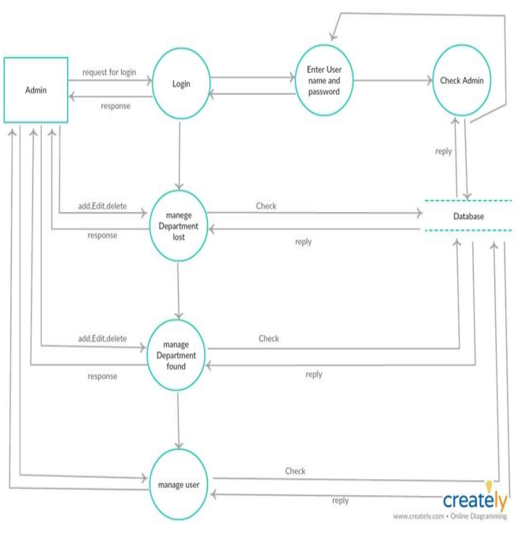

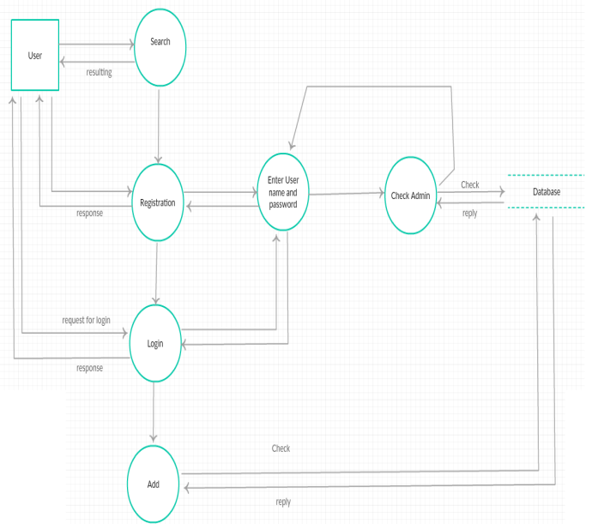

### 4.6.2 Use-Case Analyses

This is where the researchers analyzed the system through to identifying the requirements of a system and the information used to both define processes used and classes which will be used both in the use case diagram and the overall use case in the development or redesign of a software system or program.

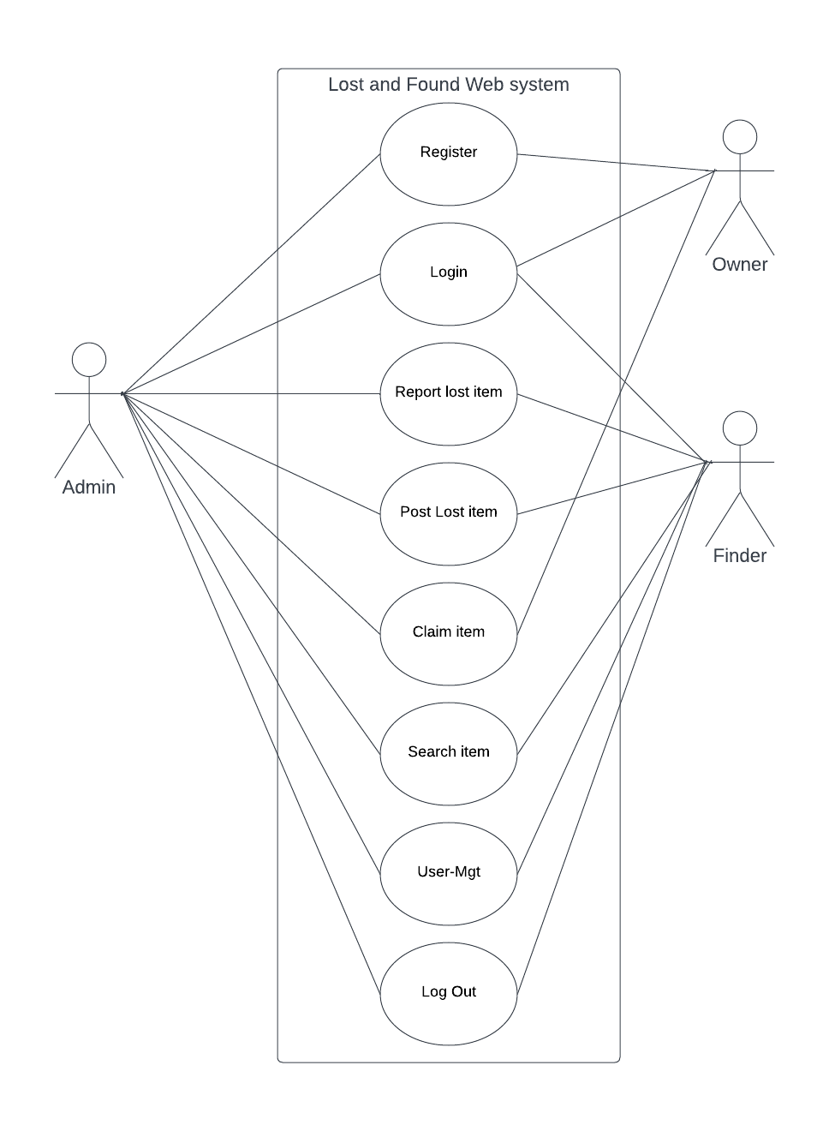

### A4.6.3 Entity Relationship Diagrams

This is a model that the research team used to describe the interrelated things of interest in a specific domain of knowledge of ecommerce system. This ER model is composed of entity types and specifies relationships that can exist between entities.

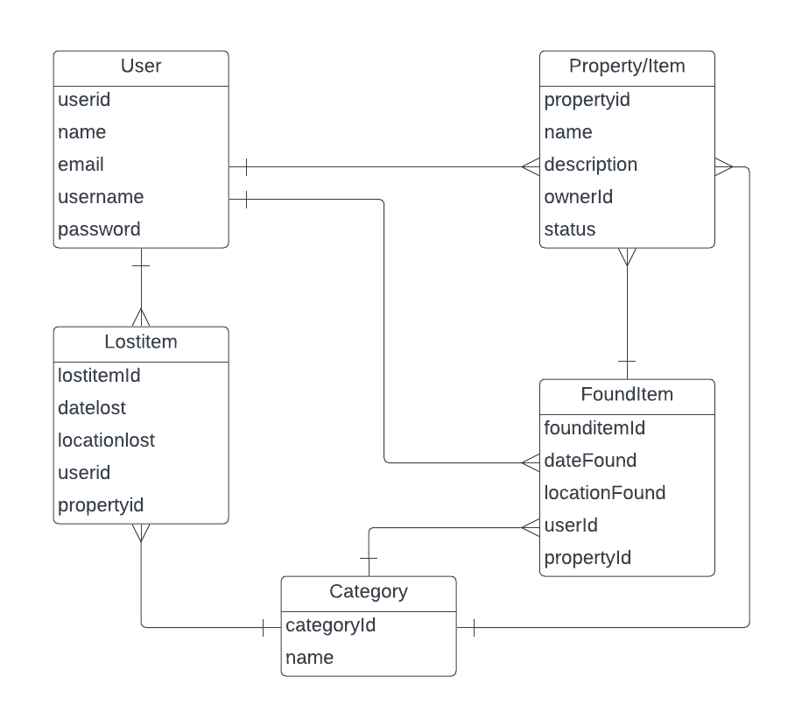

**CHAPTER FIVE**

# SYSTEM DEVELOPMENT AND PRESENTATION

## 5.0 Introduction

The section of the project report made analysis on the system and its functions as well as both screen shots for the website interfaces and the databases for the various pages and tables in the system.

## 5.1 Systems Development

The system was designed to enable students to track, find and regain ownership of lost items with in the institution. This is after a thorough review of the traditional way of location and tracking items that included making announcements on notice boards where one could not easily get back their item without prior proof.

The web system was developed with one authentication or authorization level for the users to login, strictly view and manage their information, view and make orders for their desired products.

It was designed based on the problems statement as reflected in chapter one of this report, however among other challenges and limitation which prompted the development of this system among others included; wastage of resources by people in the old mode of shopping, wastage of time, inconsistency in the prices of the company products.

### 5.1.1 System languages used

## HTML

HTML stands for Hyper Text Markup Language and is used to create and structure content on the web. HTML was used to come up with the interfaces that the user interacts with when he/she visits the website.

## CSS

CSS Stands for "Cascading Style Sheet." Cascading style sheets are used to format the layout of Web pages. In the proposed ecommerce system, CSS was used to achieve a well display layout of the front-end system of the e-commerce system.

## Python Django

This is a popular web framework that simplifies the development of web applications using the Python programming language. It uses MVC Architecture: Django follows the Model-View-Controller (MVC) architectural pattern. It provides a clean separation of concerns, making it easier to organize and maintain your codebase. Models define the data structure, views handle user requests and responses, and templates handle the presentation layer. It also uses ORM (Object-Relational Mapping): Django includes a powerful Object-Relational Mapping (ORM) layer that allows you to interact with your database using Python objects. It abstracts away the complexities of SQL queries and provides a convenient way to define and manipulate database tables and relationships. Therefore this was used as the back end language to develop the logic and functionality of the system.

**Bootstrap**

Bootstrap is a free, open source front-end development framework for creation of websites and web apps. Designed to enable responsive development of mobile-first website, Bootstrap provides a collection of syntax for template designed. Bootstrap was used in the e-commerce website to achieve fast development of responsive site on different devices both desktop and mobile devices.

## SQLite 3 (Structured Query Language)

SQLite3 is a lightweight, server less, and self-contained relational database management system (RDBMS) implemented as a C library. It is widely used due to its simplicity and ease of integration into applications. SQLite3 databases are stored as single files, making them portable and easy to manage. It supports standard SQL syntax and provides ACID (Atomicity, Consistency, Isolation, Durability) properties for data integrity. SQLite3 is commonly used in embedded systems, mobile applications, and small-scale projects where a full-fledged client-server database system is not required.

**5.2 System Presentation**

### 

### Figure 1: Login Screen

This page allows a registered user to login into the system. It comprises of a form to capture the username and password from the user.

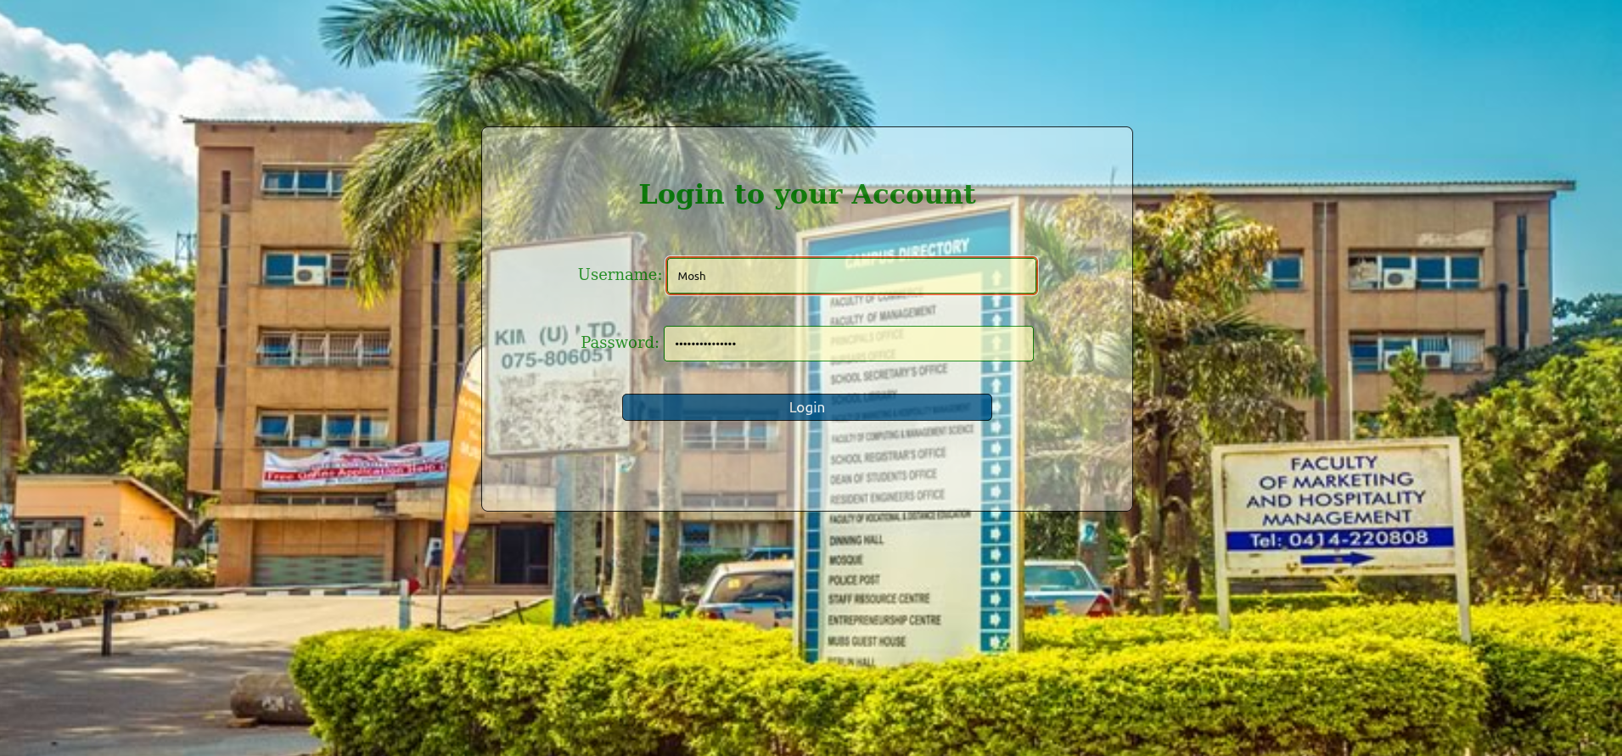

### 

### Figure 2: Registration Page

This page allows a new user to register or sign up with the system. It comprises of a form to capture the user details or information and it also has a link to redirect the registered users to the login page.

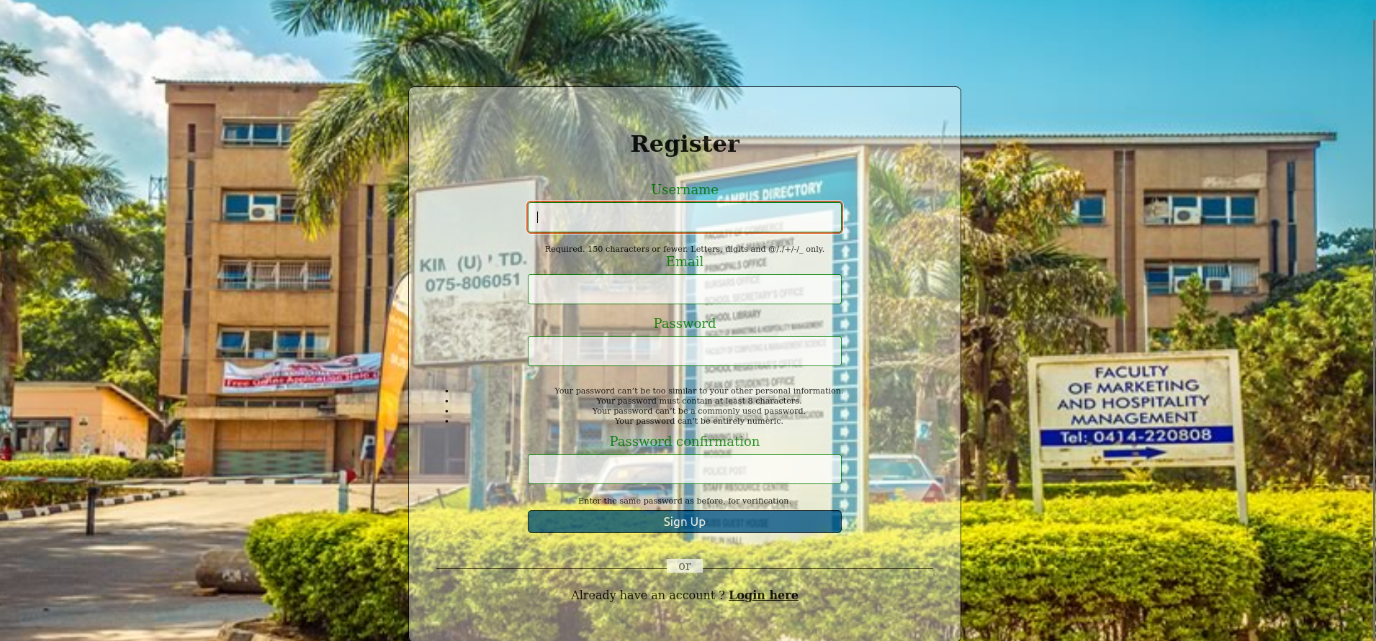

### Figure 3: Admin Dashboard.

This allows the admin to manage the system.

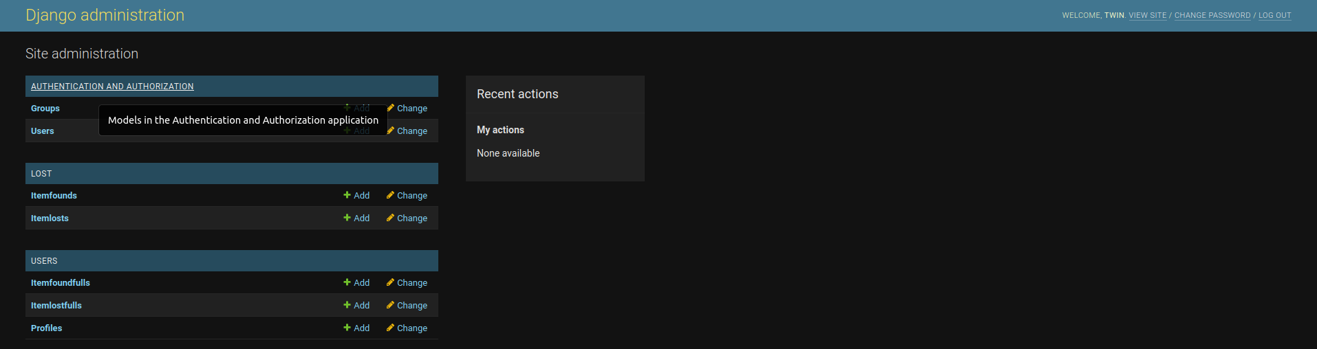

### 

### Figure 4: Post Lost Items’ page

This page enables the user to post a lost item on the platform.

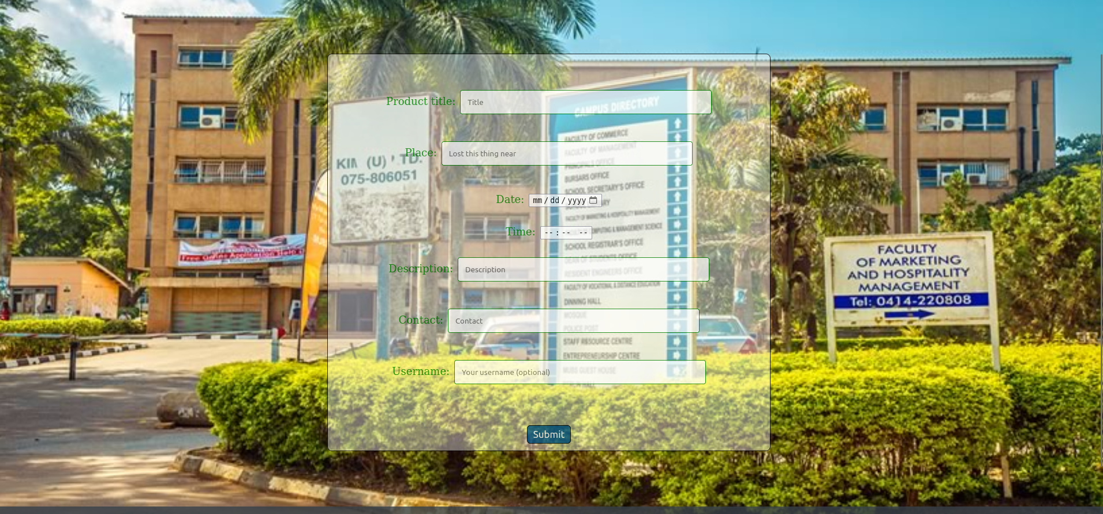

### Figure:5 Post Found Items’ page

This page enables the user to post the found item such that its seen by others to see who it belongs to.



### 

### Figure 6: Profile Update page

This page enables the user to customize their details and update their profiles if they want to, for example their username, password, profile pictures and the like.

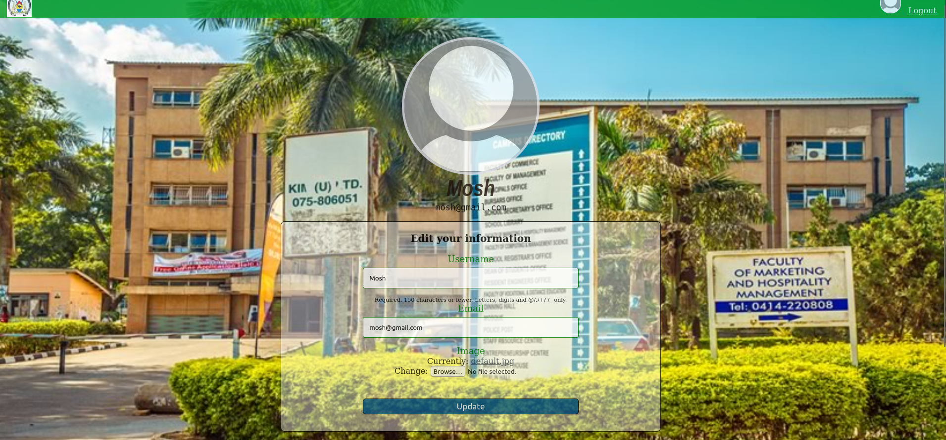

### 

### Figure 7:About_Us page

This page gives a brief description of what the system doe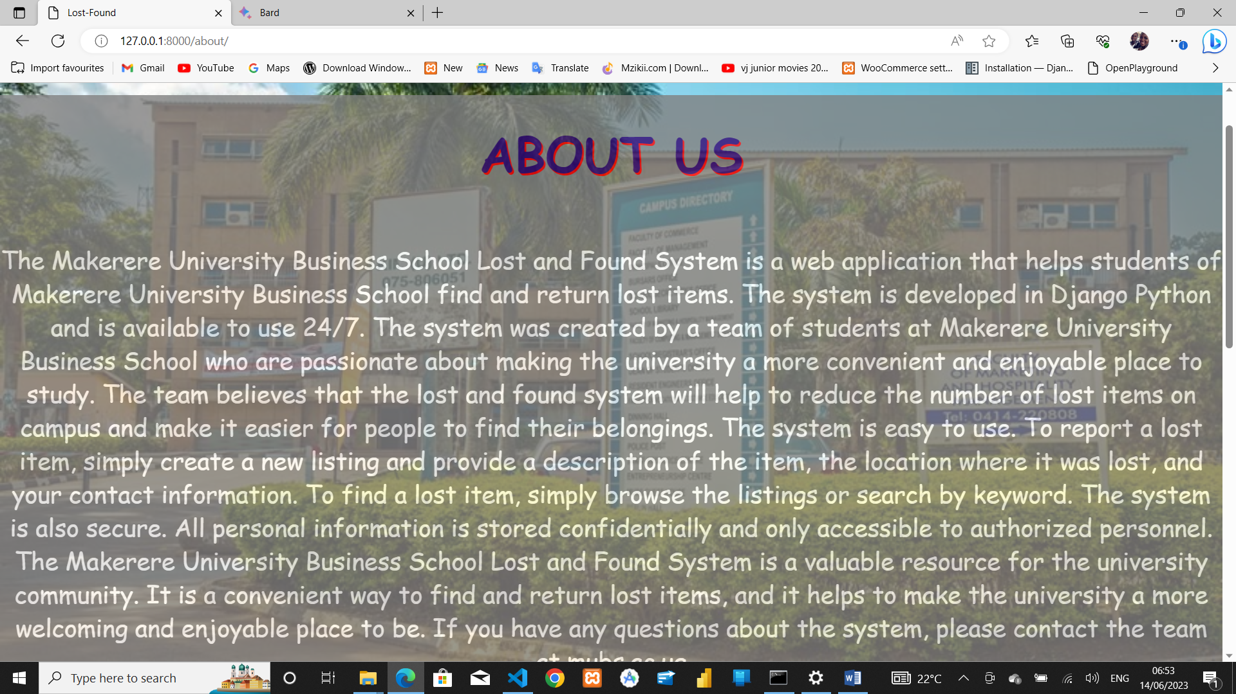s.

### 

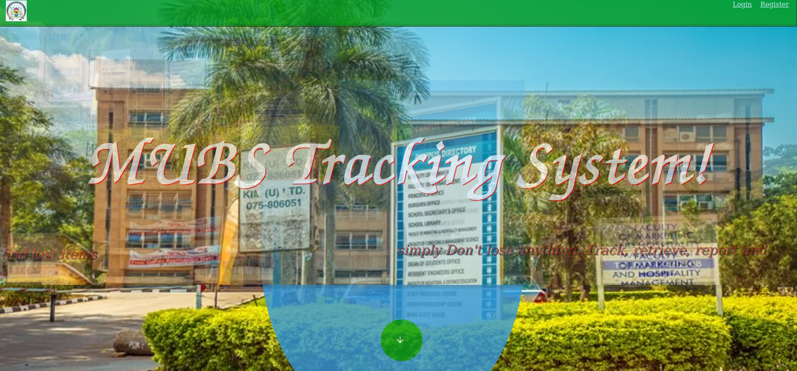Figure 8: Home page.

This page is displayed upon searching for the website in any search engine.

# CHAPTER SIX

# CONCLUSIONS AND RECOMMENDATIONS

## 6.0 Introduction

This chapter comprises of the conclusions and recommendations the research team has about the findings and the interpretations of the study based on analysis.

## 6.1 Conclusions

The researchers analyzed the current systems and observed that the systems had a lot of challenges that customers were complaining about and was inconsistent thus the team had to develop a web based application to solve those issues and make it easy for the users to find and track their lost items with minimum efforts and time resources.

The integrated lost and found web- system solution was designed using the most secure and common Python framework Django. The project further involved review of available literature about the available system that helped throw some light on how to go about with development of the new system. The project was successfully developed and now properly functioning as specified by the requirements.

## 6.2 Recommendations

The users, like students and admin should be informed and also taught how to use the system for efficiency, consistency and quality. the users should also be sensitized about the benefits associated with using the system so as to appreciate it.

Security wise, the system has an encrypted password that must be used by the administrator so as to access information needed thus preventing the system from unauthorized access. This implies that there should be continuity in ensuring that security is at standard.

Due to the changing trends in technology the web solution needs to be updated regularly to enhance the changing needs of users.

## 6.4 Limitations of the project

The team faced the following challenges in the study

There were a lot of additional system requirements like the site being developed separately from the admin dashboard which required extra skills made the development to slow down.

The Project time scope was not enough for all the dynamic contents to be implemented into the system including the mobile application that was needed.

## 6.5 Future Research

* Development of a mobile app for Android and iOS platforms for the developed web-based ecommerce system for online shopping.
* Extending the system to also be used in different institutions/ universities of the country.

# References:

Kyambogo University. (n.d.). Lost and found. Retrieved from https://kyu.ac.ug/lost-and-found/

Nantume, L. (2019, February 25).

KCCA lost and found property department reunites owners with their items. Daily Monitor. Retrieved from: https://www.monitor.co.ug/News/National/KCCA-lost-and-found-property-department-reunites-owners-with-their-items/688334-4991454-49r6mr/index.html

Njuki, J. (2016). An Investigation into the Role of Lost and Found Units in Managing Lost Items in Uganda. International Journal of Business and Social Science, 7(11), 28-39.

Bizfluent. (2019). what is an action research model in education? Retrieved from https://bizfluent.com/info-12170841-action-research-model-education.html

Cohen, L., Manion, L., & Morrison, K. (2017). Research methods in education. Routledge.

Krejcie, R. V., & Morgan, D. W. (2022). Determining sample size for research activities. Educational and Psychological Measurement, 30(3), 607-610.

Kvale, S., & Brinkman, S. (2019). Interviews: Learning the craft of qualitative research interviewing. Sage Publications.

American Psychological Association. (2017). Ethical principles of psychologists and code of conduct. https://www.apa.org/ethics/code/index

Ahmad, M., Rahman, A., & Alharbi, A. (2021). Security and Privacy of RepoApp: A Mobile-Based Lost and Found System. Wireless Personal Communications, 120(2), 2097-2117.

Chang, Y., Lee, J., Lee, H., & Kim, S. (2020). Development and evaluation of a campus lost and found system using a mobile application. International Journal of Human-Computer Interaction, 36(13), 1243-1253.

Kim, K., Choi, J., Park, J., & Kim, S. (2019). RepoApp: A Mobile Application for Lost and Found Item Management. Mobile Information Systems, 2019, 1-8.

Alenezi, H., Al-Salman, A., & Al-Rowaily, M. (2017). Development and implementation of a lost and found system for a shopping mall. Journal of King Saud University-Computer and Information Sciences, 29(4), 503-510.

Kumar, A., Das, A. K., & Sahoo, S. (2020). Development and Implementation of a Lost and Found Web System for a City. In Proceedings of the 4th International Conference on Communication and Electronics Systems (pp. 633-638).

Liang, X., Wu, J., & Zhou, X. (2019). Development and Implementation of a Lost and Found Web System for University Campus. Journal of Physics: Conference Series, 1197(6), 062027